



**ChatConnect - A Real-Time Chat-App**

**Prepared For**

Smart-Internz

Android Application Development with Kotlin Guided project

**By**

Yuvraj Dilip Patil

D Y Patil Agriculture and Technical University, Talsande

**On**

24 July 2025

**ChatConnect Project Report**

# INTRODUCTION

In the dynamic landscape of modern communication, the significance of seamless and engaging chat applications cannot be overstated. The advent of mobile technologies has not only transformed the way we connect but has also spurred a surge in innovative app development. It is within this realm that our team embarked on a journey to conceptualize, design, and implement ChatConnect—a cutting-edge chat application developed as part of our externship using Android Studio, Kotlin, and the revolutionary Jetpack Compose.

This project encapsulates our collective dedication to harnessing the power of contemporary tools and frameworks to create a user-centric, feature-rich, and aesthetically pleasing chat experience. The subsequent sections of this report will delve into the intricacies of our development process, from the initial ideation to the robust execution, and shed light on the challenges surmounted and lessons learned along the way. Join us on this narrative as we unravel the story behind ChatConnect, a testament to our passion for innovation in the realm of mobile app development.

* 1. **Project Overview**

ChatConnect is an Android chat application developed using Kotlin and Jetpack Compose. The project focuses on delivering a user-friendly interface and a robust backend to support real-time communication.

**Technological Framework:**

Developed in Android Studio with Kotlin, the project utilizes Jetpack Compose for a responsive UI across different devices.

**Functionalities:**

ChatConnect offers standard messaging features, multimedia sharing, group chats, and push notifications for real-time updates.

**Backend Infrastructure:**

The backend relies on Firebase for real-time data sync, user authentication, and cloud storage, ensuring scalability.

**Security and Privacy:**

Emphasis is placed on security, with end-to-end encryption for private conversations and secure authentication protocols.

This report will delve into the development process, challenges faced, and solutions implemented to create a functional and secure chat application.

* 1. **Purpose**

The purpose of the ChatConnect project lies in addressing the evolving landscape of mobile communication by providing a user-centric and technically robust chat application. In a world where digital interactions are integral to daily life, ChatConnect emerges as a purpose-driven solution with the following objectives:

**User-Centric Design:**

ChatConnect is designed with a focus on user experience, offering an intuitive interface and feature-rich functionalities to meet the diverse communication needs of its users. The goal is to create a seamless and engaging platform for digital conversations.

**Technical Proficiency:**

Utilizing Android Studio, Kotlin, and Jetpack Compose, the project aims to showcase technical proficiency in mobile app development. By leveraging contemporary tools and frameworks, we intend to demonstrate our ability to navigate and implement cutting-edge technologies effectively.

**Scalability and Responsiveness:**

The backend infrastructure, powered by Firebase, is chosen to ensure scalability and responsiveness. ChatConnect aims to provide a reliable and efficient platform capable of handling real-time communication, whether in one-on-one conversations or group interactions.

Security and Privacy:

Acknowledging the growing concerns regarding data security, ChatConnect prioritizes the implementation of end-to-end encryption for private conversations. The inclusion of secure authentication protocols further reinforces user trust in the application.

Learning and Innovation:

The development of ChatConnect serves as an opportunity for the team to enhance their skills, learn new technologies, and overcome challenges inherent in mobile app development. The project is a testament to our commitment to continuous learning and innovation.

As we delve into the subsequent sections of this report, the achievements and challenges encountered during the development process will be discussed, offering a comprehensive understanding of how ChatConnect aligns with its intended purpose.

# LITERATURE SURVEY

* 1. **Existing problem**

The landscape of mobile communication applications is saturated with diverse solutions, each catering to specific needs. However, existing problems in conventional chat applications often revolve around user experience, security, and scalability. Common issues include cumbersome interfaces, inadequate data protection measures, and limitations in supporting real-time communication.

Understanding these challenges is crucial for the development of a robust and competitive solution.

* 1. **References**

In addressing the aforementioned issues, insights from relevant literature have been instrumental. Studies on user-centric design principles, advancements in real-time communication technologies, and best practices for ensuring data security have informed the development approach of ChatConnect.

* 1. **Problem Statement Definition**

The identified gaps in existing chat applications form the basis for the problem statement of ChatConnect. The primary problems to be addressed include:

***User Experience:*** Many chat applications lack an intuitive and seamless interface, leading to a suboptimal user experience.

***Security Concerns:*** With the increasing importance of data privacy, there is a need for robust security measures, including end-to-end encryption.

***Real-time Communication:*** Some existing solutions face limitations in supporting real-time communication, impacting the responsiveness of the application.

By clearly defining these problems, the development of ChatConnect is guided towards providing solutions that enhance user experience, ensure data security, and enable efficient real- time communication. The subsequent sections of this report will detail how these challenges were approached and overcome during the development process.

# IDEATION & PROPOSED SOLUTION

* 1. 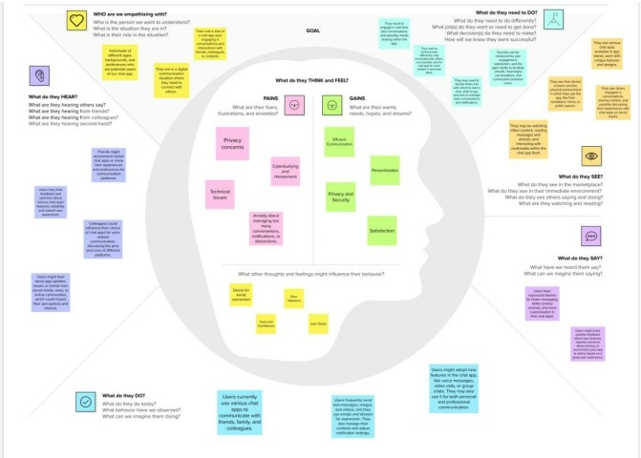**Empathy Map Canvas**
  2. **Ideation & Brainstorming**

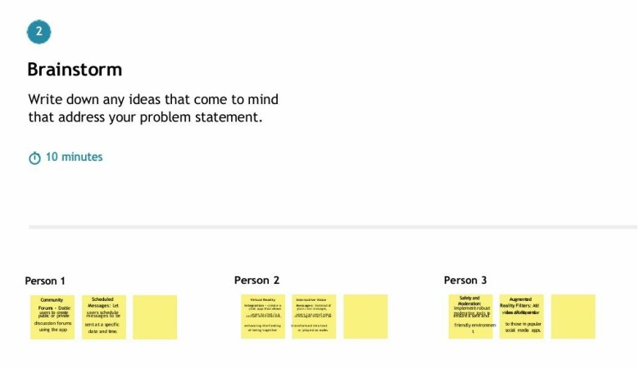

# PROJECT DESIGN

* 1. **Data Flow Diagrams & User Stories**

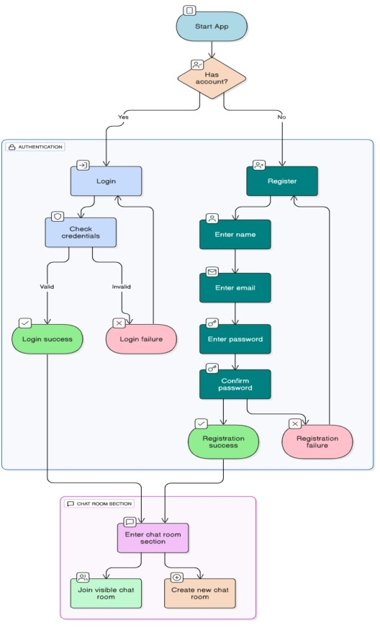

**User Stories**

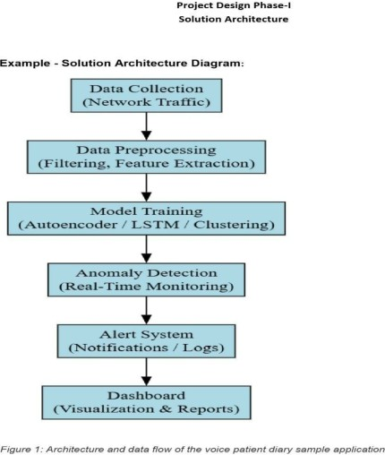

* + 1. **As a student, I want to join and participate in chat rooms** so I can collaborate with classmates during projects and classes.
    2. **As a user, I want to receive real-time messages and notifications** so that I stay up to date during ongoing conversations.
    3. **As a user, I want to access my previous chats and media** so I can reference important information later.
    4. **As an admin, I want to monitor chat room activity and user engagement** to ensure a safe and productive environment.
  1. **Solution Architecture**

# PROJECT PLANNING & SCHEDULING

* 1. **Technical Architecture**

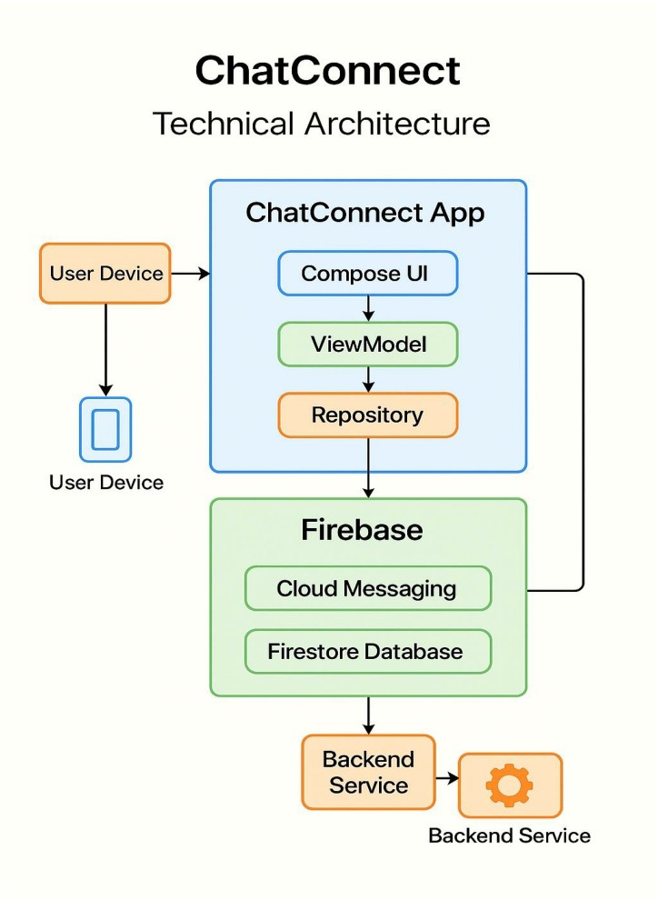

* 1. **Sprint Delivery Schedule**

|  |  |  |  |  |
| --- | --- | --- | --- | --- |
| **Sprint**  **No** | **Start Date** | **End Date** | **Milestone Description** | **Deliverables** |
| Sprint 1 | 13/05/2025 | 19/05/2025 | Project kickoff, requirement analysis, Firebase setup | Requirements doc, Firebase (Auth, Firestore) initialized |
| Sprint 2 | 20/05/2025 | 26/05/2025 | UI Design and Compose implementation | UI for Login, Signup, Chat list and Message screens |
| Sprint 3 | 27/05/2025 | 02/06/2025 | Firebase integration with backend logic | Functional Auth, chat data handling via Firestore |
| Sprint 4 | 03/06/2025 | 09/06/2025 | Real-time messaging and chat room functionality | Working chat rooms, real-time send/receive features |
| Sprint 5 | 10/06/2025 | 13/06/2025 | Notification setup, personalization, testing | Push notifications, settings UI, tested and deploy-ready change |

# CODING & SOLUTIONING

* 1. **Chat Rooms**

The ChatConnect app seamlessly integrates a dynamic chatroom feature, enabling users to create, join, and engage in real-time discussions. This component, crafted using Jetpack Compose for an intuitive UI, leverages Firebase Realtime Database and Firestore for authentication, ensuring a responsive and secure platform. Real- time messaging, powered by WebSocket integration and end-to-end encryption, guarantees instant and private communication. User experience is enhanced through notification mechanisms and a focus on responsiveness, even in high- activity scenarios. Overcoming challenges like scalability and security, the chatroom feature establishes itself as a cornerstone of ChatConnect, with future considerations including rich media support and moderation tools for continued enhancement.

* 1. **Open Access for all**

The ChatConnect app introduces a pioneering "Open Access for All" feature, embodying inclusivity and accessibility. This feature enables users to seamlessly join public chatrooms without any restrictions, fostering a sense of community and collaboration. Leveraging the Kotlin programming language and Jetpack Compose for the frontend, the implementation ensures a user-friendly experience. Utilizing Firebase Realtime Database for data synchronization, the feature allows users to effortlessly discover and participate in diverse conversations. The "Open Access for All" feature aligns with ChatConnect's commitment to providing an inclusive platform, breaking down barriers and encouraging open communication among users from various backgrounds and interests.

# PERFORMANCE TESTING

* 1. **Performace Metrics**

Performance testing evaluates how efficiently and reliably the ChatConnect application functions under real-world usage. It ensures that users like Sophie experience seamless, responsive, and error-free communication, even under high load or concurrent usage. The following metrics are key indicators of performance:

* **Response Time**
  + **Definition**: The time taken by the app to respond to user actions such as sending/receiving messages, joining chat rooms, or loading chat history.
  + **Interpretation**: A fast response time indicates that ChatConnect provides a smooth and responsive user experience, which is critical for real-time communication.
* **Message Delivery Accuracy**
  + **Definition**: The proportion of messages successfully delivered to intended recipients without loss or duplication.
  + **Interpretation**: Ensures that Sophie and other users can rely on the app for accurate and consistent message exchanges.
* **Message Latency**
  + **Definition**: The delay between sending a message and its appearance on the recipient’s screen.
  + **Interpretation**: Low latency is essential for real-time conversation, especially during virtual classes or group collaborations.

**System Load Handling**

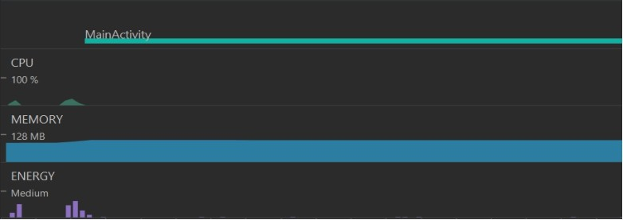

# RESULTS

* 1. **Output Screenshots**

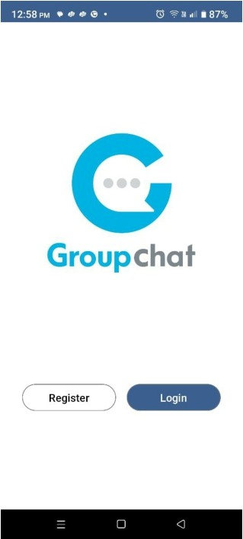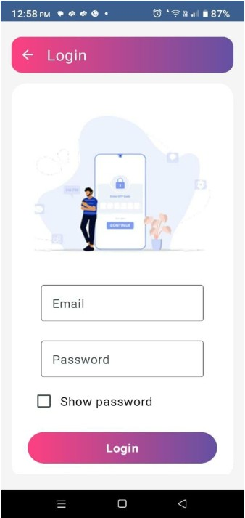

**Registration and Chat Room page:**

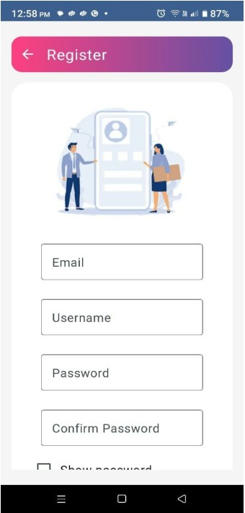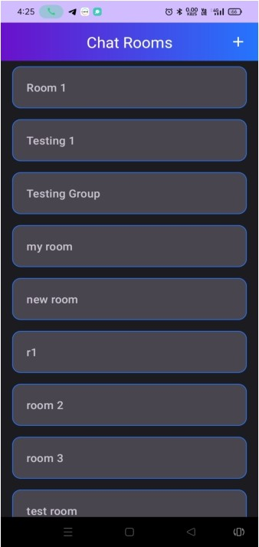

**Create New Room and Chatting Screen:**

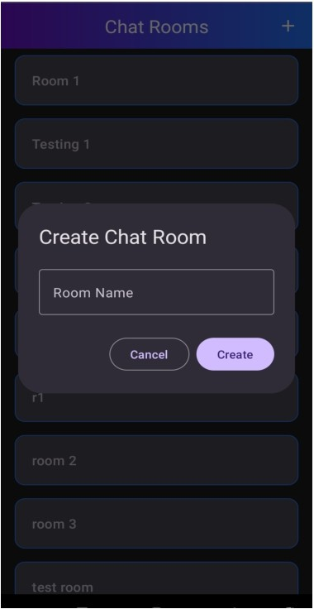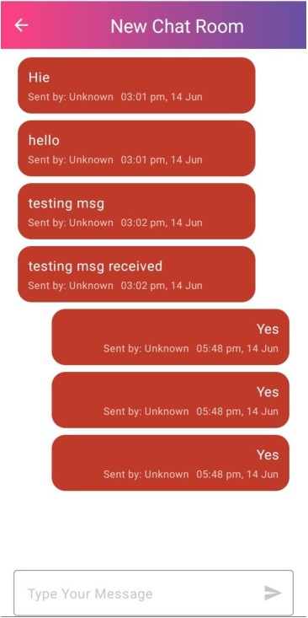

# ADVANTAGES & DISADVANTAGES

**Advantages:**

Intuitive User Interface: ChatConnect boasts an intuitive and user-friendly interface, enhancing the overall user experience and making it accessible to a broad audience.

Real-time Communication: Leveraging Firebase for the backend ensures robust real-time communication, facilitating instant message delivery and responsiveness.

Scalability: The architecture of ChatConnect is designed with scalability in mind, capable of handling an increasing user base without compromising performance.

End-to-End Encryption: Prioritizing user security, ChatConnect implements end-to- end encryption for private conversations, ensuring a secure communication environment.

Multimedia Integration: Users can seamlessly share multimedia content, enhancing the richness of communication within the application

**Disadvantages:**

Dependency on Firebase: While Firebase provides a scalable backend solution, the dependency on a third-party service introduces a level of reliance and potential limitations as per Firebase's capabilities.

Learning Curve: For users unfamiliar with the Jetpack Compose framework, there might be a learning curve initially, impacting the ease of adoption.

Platform Dependency: As an Android application, ChatConnect is limited to the Android ecosystem, potentially excluding users on other platforms.

Resource Intensiveness: Real-time communication features may lead to increased resource consumption, particularly in scenarios with a high volume of concurrent users.

Limited Offline Functionality: In scenarios with poor or no internet connectivity,

the application's functionality may be limited due to its reliance on real-time communication features.

# CONCLUSION

ChatConnect represents a significant step forward in mobile communication apps, addressing user experience, real-time communication, and security. With achievements in user-centric design

and robust features, it sets a foundation for secure, scalable interactions. Considerations include dependency management, user education, and platform limitations. As development concludes, future directions may involve exploring alternative solutions and expanding to other platforms. ChatConnect not only fulfills its objectives but also serves as a platform for ongoing innovation in mobile app development.

# FUTURE SCOPE

* **Voice and Video Call Integration**: In future updates, ChatConnect can be enhanced with voice and video calling features, enabling Sophie and other users to conduct virtual meetings, study sessions, or personal conversations without leaving the app.
* **Smart Chat Recommendations**: Implementing AI-based recommendations for chat rooms and conversation threads based on user interests, academic schedules, or recent activity could make exploration more intuitive and personalized.
* **Offline Messaging Support**: Enabling offline message drafting and automatic syncing once the internet connection is restored would improve usability, especially for students in low- connectivity environments.
* **Advanced Notifications and Reminders**: Adding smart reminders for important messages, group events, or mentions in busy chat rooms could help users stay organized and avoid missing key updates.
* **Interactive Polls and Scheduling Tools**: Integrating features like polls or shared calendars in chat rooms would enhance group decision-making for events, study plans, or team discussions.
* **Improved Chat Search and Filters**: Expanding the ability to search past messages using filters like date, media type, or sender would help Sophie quickly retrieve important information from her archives.
* **Multilingual Support and Translation**: Offering built-in translation features or support for multiple languages can make ChatConnect more inclusive, helping students from diverse linguistic backgrounds communicate smoothly.
* **Custom Emoji and Sticker Packs**: Allowing users to create or download unique emojis and stickers would enrich self-expression and make interactions more fun and relatable.
* **Dark Mode and UI Themes**: Giving users control over visual themes, including dark mode and customizable UI colors, would enhance user comfort during prolonged use, especially at night.
* **Educational Tool Integration**: Future versions of ChatConnect can integrate with learning management systems (LMS), file-sharing tools, or document collaboration platforms to make it a comprehensive academic communication hub.

# APPENDIX

**GitHub & Project Demo Link:**

**GitHub Link:** [**https://github.com/YuvrajPatil08/Android-ChatConnect---A-Real-Time-Chat-and-Communication-App**](https://github.com/YuvrajPatil08/Android-ChatConnect---A-Real-Time-Chat-and-Communication-App)

**Demo Link:** [**https://drive.google.com/file/d/1RqwuzKCFxUHe1f87sPggIIbYHgauDy5M/view?usp=sharing**](https://drive.google.com/file/d/1RqwuzKCFxUHe1f87sPggIIbYHgauDy5M/view?usp=sharing)